

**IT3030**

**Programming Application and Framework**

**3rd Year, 1st Semester**

PAF Project Assessment

**SellNBuy system**

Submitted to

Sri Lanka Institute of Information Technology

Bachelor of Science Special Honors Degree in Information Technology

26.04.2022

**Group details**

**Group Number: No group List –IT17028424**

**Group Members with workload:**

|  |  |  |  |  |
| --- | --- | --- | --- | --- |
|  | **Name** | **IT Number** | **Function** | **Workload** |
| 1 | Ekanayake E.M.W.C.L  (Member 1) | IT17028424 | User Management | * User Loin * User Registration * View details * Delete and update users |
| 2 | Member 2 | ‘’ | Shopping Cart - Admin | * Admin Loin * Insert, View, Update and Delete items |
| 3 | Member 3 | ‘’ | Shopping Cart - User | * User Loin * Insert, View, Update and Delete items |
| 4 | Member 4 | ‘’ | Payment | * View payments * Make payments * Update and Delete details |

**Acknowledgement**

When I embarked this project, it appeared to me as onerous task. Slowly as I progressed I did realize that I was not alone after all.

I wish to express my gratitude to my teachers as well as my staff who gave us the golden opportunity to do this wonderful project under the PAF Subject, I would also like to express my gratitude to everyone who extended their kind help, guidance and suggestion without which it could not have been possible for me to complete this project report. My sincere thanks to my all entire faculty members.

**Content…**

|  |  |  |  |
| --- | --- | --- | --- |
|  |  | | **Page No.** |
|  | **SE Methodology** | | **04** |
|  | **Stakeholder analysis** | **- (Onion diagram)** | **04** |
|  | **Requirements analysis** | **- (Functional and Non-functional requirements)** | **05** |
|  | **Requirements modeling** | **- (Use case diagram)** | **05** |
|  | **Overall architecture** | | **05** |
|  | **Activity diagrams** | | **05** |
|  | **Any other relevant design diagrams** | | **08** |
|  | **Time schedule (Gantt chart)** | | **10** |

**IX**. **Clickable URL to your GIT repo**  **10**

1. **SE Methodology**

* In here we used agile scrum methodology to build our project.
* It is easy way to build a system software for a given period.

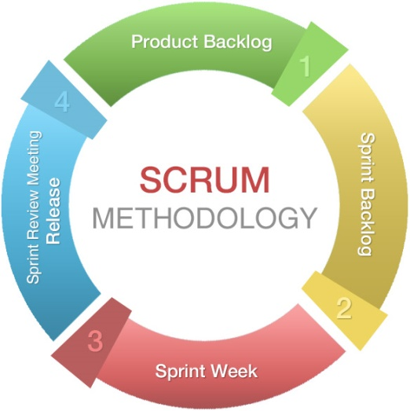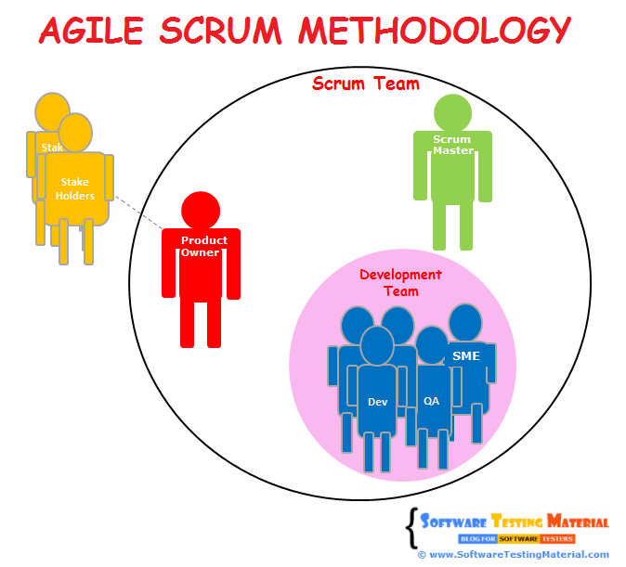

**2.Stakeholder Analysis (Onion Diagram)**

* This onion diagram shows the dependencies among parts of the project and organization.

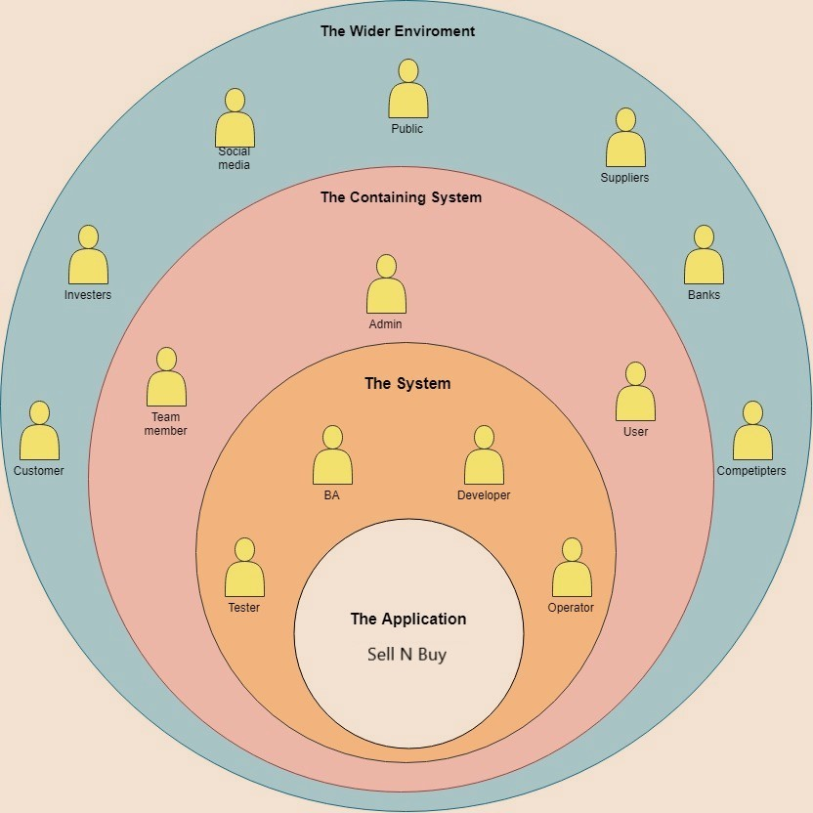

**3.Requirement Analysis**

|  |  |  |
| --- | --- | --- |
| **Functional Requirement** | **Non – functional Requirement** | **Technical Requirement** |
| 1. User management | 1. High performance | 1. Eclipse Java EE |
| 1. Item management | 1. Usability | 1. Maven |
| 1. Payment management | 1. Time management | 1. MySQL |
|  | 1. Maintainability | 1. HTML, CSS (Bootstrap) |
|  | 1. Simplicity | 1. Simplicity |
|  | 1. Quality |  |
|  | 1. Consistency |  |

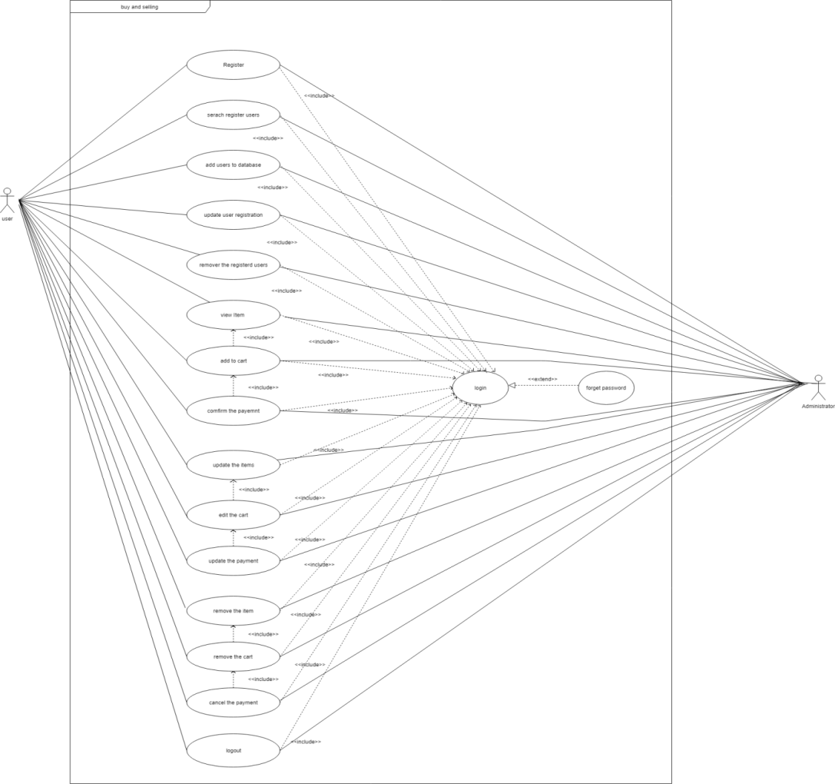**4.Requirement Modelling (Usecase Diagram)**

**5.Overall Architecture**

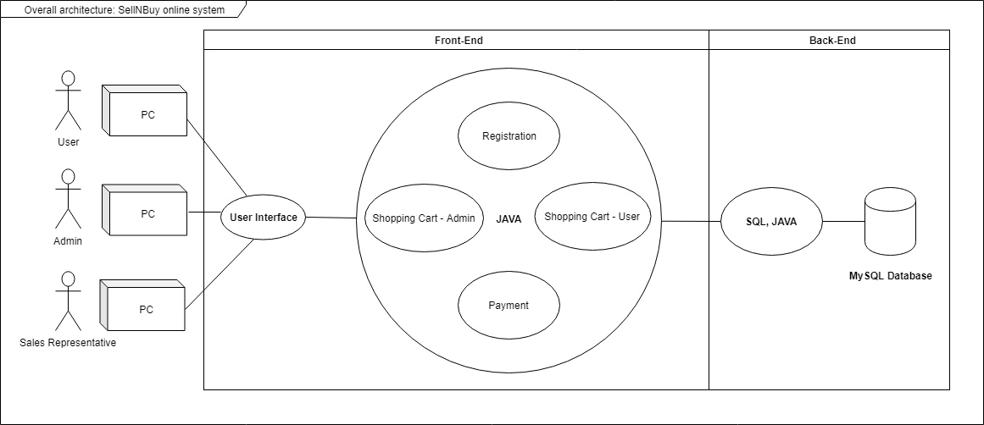

**6.Activity Diagrams (For the 4 web services)**

1. User Management (Registration)

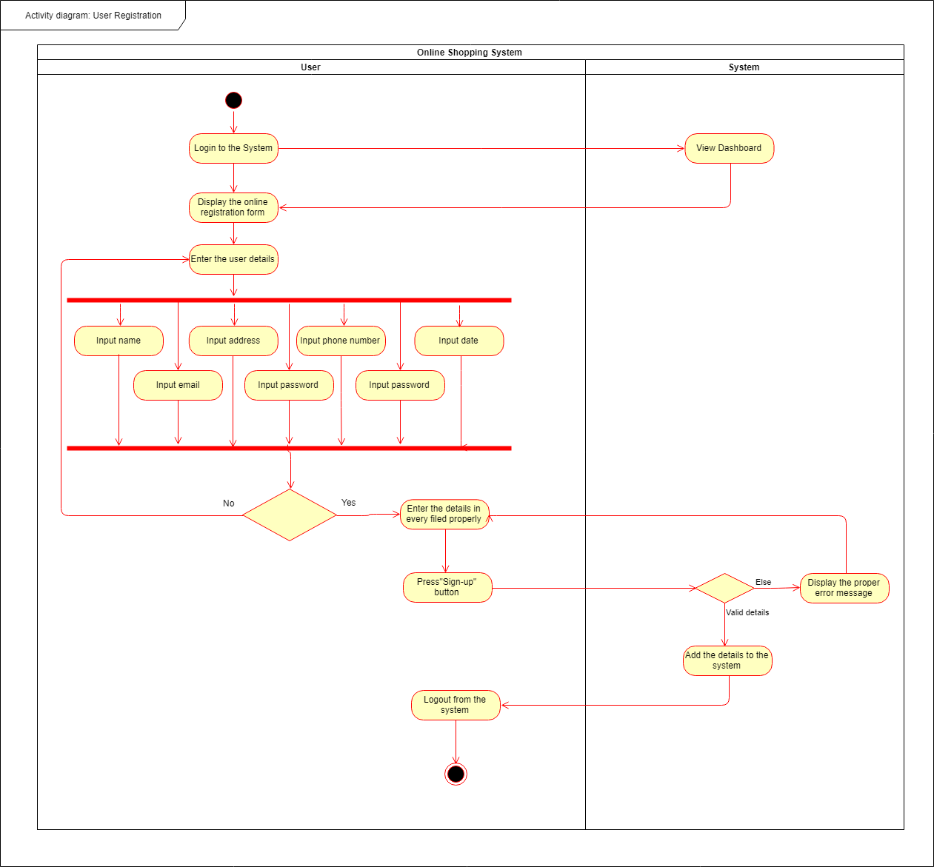

1. Shopping Cart – User

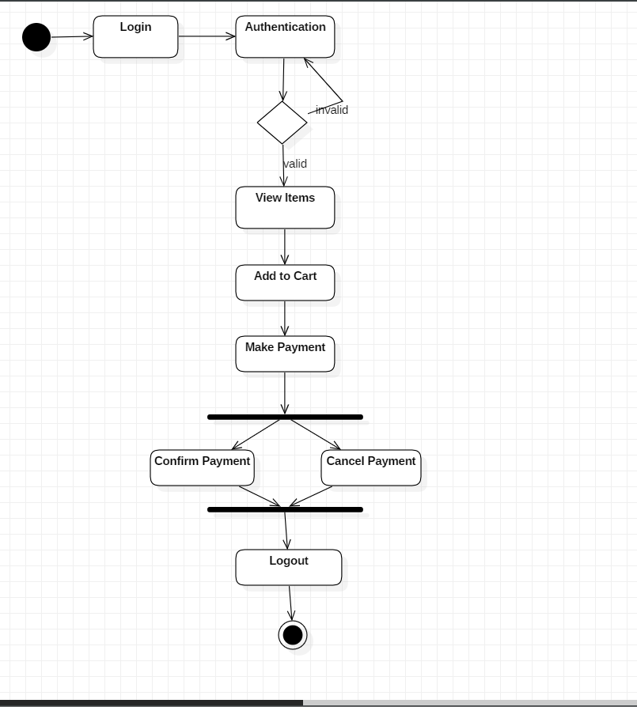

1. Shopping Cart – Admin

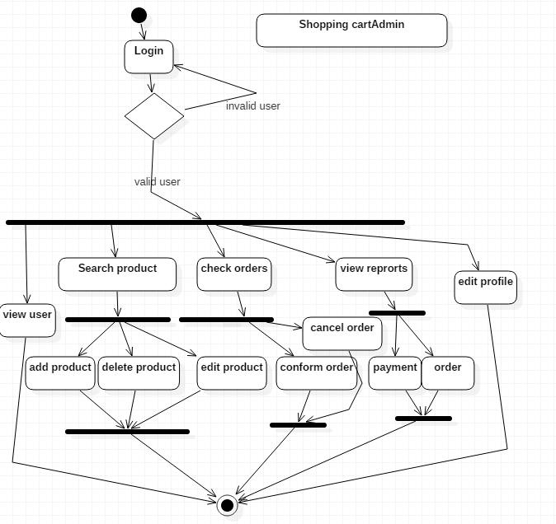

1. Payment

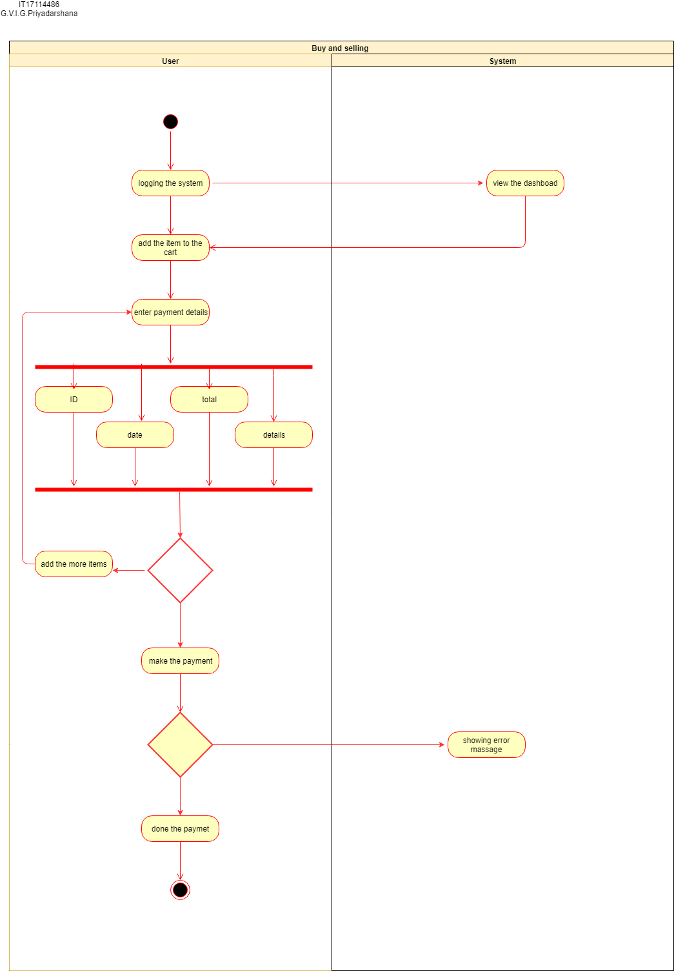

**7.Any other relevant design diagrams**

* **Class Diagram (Overall system)**

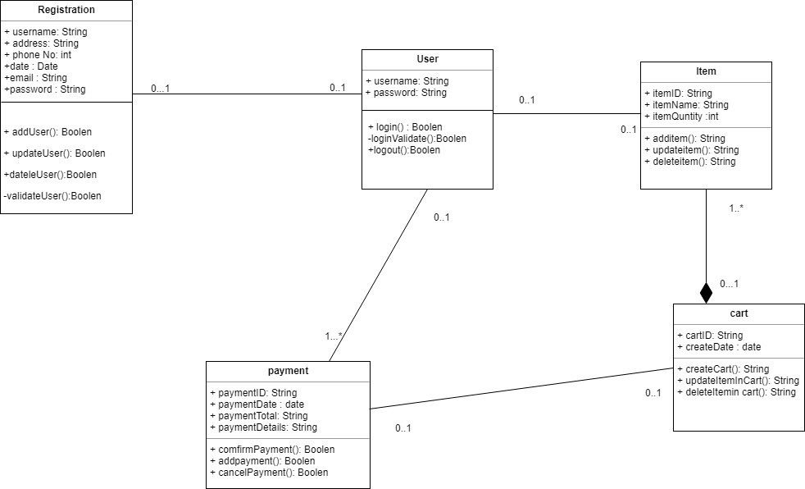

* **Flow Chart Diagram (Overall system)**

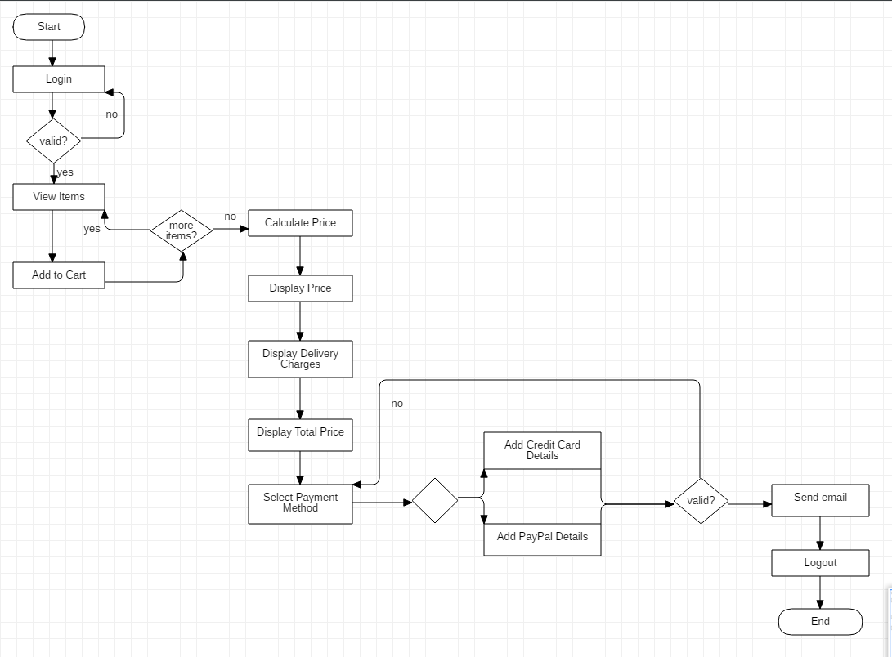

* **ER Diagram (Overall system)**

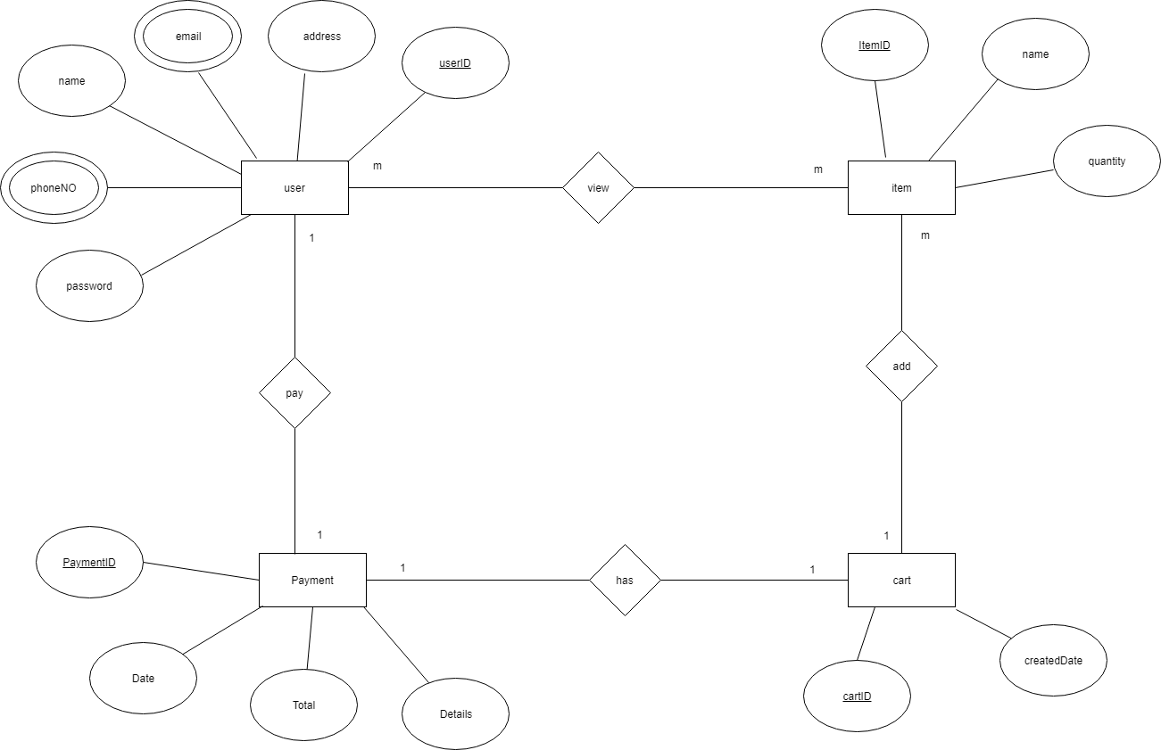

**8.Gantt Chart**

* Following is the time schedule that we suppose to finish this work.

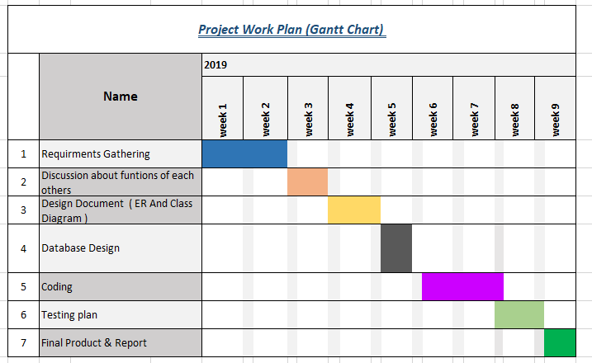

**9. Clickable URL to your GIT repo**

[**https://github.com/lakshaniekanayake/PafAssessment_IT17028424.git**](https://github.com/lakshaniekanayake/PafAssessment_IT17028424.git)